

Axtria Sales IQTM Strategic Account Planning Implementation

Business Requirements Document

28/05/2025

Copyright Axtria, Inc. All Rights Reserved.

CONTENTS

1. DOCUMENT VERSION HISTORY 3

2. INTRODUCTION 4

WHAT IS ACCOUNT AND ACCOUNT PLANNING? 4

OVERVIEW OF SAP MODULE 4

3. BACKGROUND & BUSINESS CONTEXT 5

CURRENT STATE OF ACCOUNT MANAGEMENT 5

PAIN POINTS / GAPS IN CURRENT PROCESS 5

BUSINESS DRIVERS 5

4. FUNCTIONAL SPECIFICATIONS OF ACCOUNT MANAGEMENT 7

ACCOUNT TYPES AND STRUCTURES 7

FEATURES AND FUNCTIONALITY OF ACCOUNT MANAGEMENT 7

5. PROCESS FLOW 13

ACCOUNT PLAN WORKFLOW 13

ACCOUNT PLAN 14

TOUCHPOINTS ACROSS TEAMS 15

PLANNING CADENCES (QUARTERLY, ANNUAL) 15

6. FUNCTIONAL SPECIFICATIONS OF ACCOUNT PLANNING 16

7. NON-FUNCTIONAL REQUIREMENTS 26

8. DATA REQUIREMENTS 27

9. ASSUMPTIONS AND CONSTRAINTS 29

10. DEPENDENCIES 30

11. SUCCESS METRICS 31

12. APPENDICES 32

# DOCUMENT VERSION HISTORY

|  |  |  |  |  |
| --- | --- | --- | --- | --- |
| Ver. No. | Date | Author | Revision Notes | Approved By & Date |
| 1.0 | 05/28/2023 | Ketan, Ajaya and Aman | First Draft |  |
| 1.2 |  |  |  |  |

# Introduction

## What is Account and Account Planning?

An account refers to a specific customer or client that your team is working with. It includes all the important information, activities, and plans related to that customer—such as contacts, meetings, goals, documents, and strategy. Managing an account helps your team build a strong relationship with the customer and deliver value through organized planning and collaboration.

An account plan is a detailed guide that outlines the goals, strategies, and actions for working with a specific customer or client. It helps the team stay organized, focus on what’s important, and work together to build a successful relationship and achieve shared goals.

## Overview of SAP Module

Strategic Account Planning (SAP) helps team build strong, lasting relationships with your key customers. It lets you create personalized plans for each customer, so everyone knows the goals and the steps needed to reach them. You can easily track progress, make updates, and work together to make sure your efforts lead to success for both your company and your customers. This way, your team stays organized, focused, and ready to respond to what the customer needs over time.

# Background & Business Context

Strategic Account Planning (SAP) tool helps organizations systematically manage and grow relationships with their customers. These tools facilitate in-depth account analysis, long-term planning, and coordination across cross functional teams.

Traditionally, account planning was done manually using spreadsheets or documents. However, as customer expectations, competition, and complexity increased, businesses began investing in more structured and technology-enabled approaches. Modern Strategic Account Planning tools often integrate with CRMs (like Salesforce), analytics platforms, and collaboration tools to enhance efficiency, visibility, and alignment.

## Current state of account management

The current state of account management is transitional. While the need for strategic, integrated, and data-informed account planning is clear, many organizations are still navigating siloed systems, reactive processes, and compliance constraints. However, the move toward more collaborative, technology-enabled, and outcome-focused account management is accelerating.

## Pain points / gaps in current process

* **Lack of Centralized Information**

Account information is scattered across CRM, spreadsheets, and email, making it hard to get a unified, real-time view of the customer.

* **Non-Standardized Planning**

Teams often rely on non-standardized Excel or PowerPoint plans, leading to inefficiencies, duplication of effort, and lack of visibility.

* **Siloed Cross-functional Teams**

Cross functional teams often operate in silos, causing misalignment and inconsistent messaging to key accounts.

* **Weak Stakeholder Mapping and Engagement**

Account plans often overlook critical influencers and advocacy groups, thereby weakening engagement strategies.

* **Underutilized Digital Tools**

Existing digital tools are underutilized due to lack of training, usability issues, or unclear ownership within the organization.

## Business drivers

* **Customer Growth**

Helping key accounts grow their business by aligning solutions with their plans, market entry, or increased sales goals.

* **Improved Collaboration**

Enabling better teamwork across internal account teams through shared plans, clear responsibilities, and real-time updates that drive unified execution.

* **Unified Account Strategies**

Enable Cross-functional teams to work together on unified account strategies.

* **Consolidated Account View**

Consolidate data from multiple sources to provide a comprehensive, real-time picture of accounts and stakeholders.

* **Influencer and Advocacy Mapping**

Identify and track all key influencers, KOLs, and advocacy groups to tailor engagement strategies.

* **Proactive Engagement Approach**

Shift from reactive selling to proactive, value-based relationship building aligned with customer outcomes.

* **Compliance and Audit Readiness**

Maintain audit trails and standardized processes to meet regulatory requirements and reduce compliance risk.

* **Growth Opportunity Identification**

Identify up-sell, cross-sell, and renewal opportunities with better account insights and aligned plans.

* **Data-Driven Decision Making**

Leverage integrated analytics to measure account health, forecast outcomes, and optimize resource allocation.

* **Standardized Planning Adoption**

Facilitate consistent adoption of modern planning practices and tools across geographically dispersed teams.

# Functional Specifications of Account Management

## Account Types and Structures

SalesIQ platform supports a flexible account hierarchy that can be easily created, modified, or removed as needed. The structure allows at least three levels of accounts, each with its own account plan and visibility into related accounts. This hierarchy provides a clear and organized view of how accounts relate across different levels.

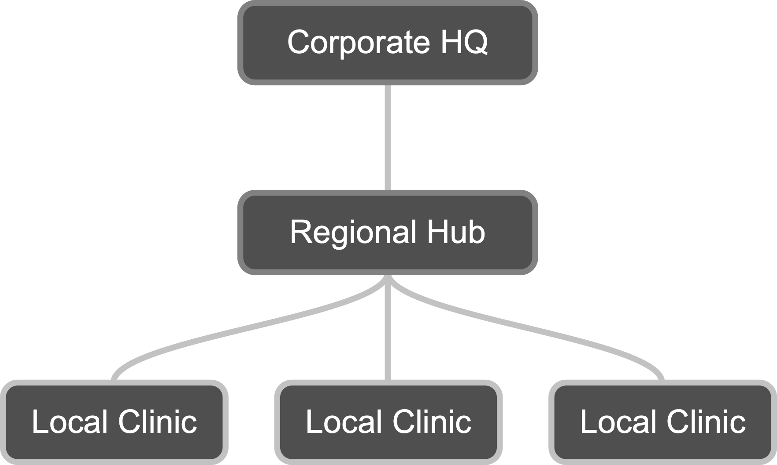

The "Current" label is used to highlight the account that is actively being viewed or worked on within the hierarchy. This helps users quickly identify their point of focus, especially when navigating between multiple related accounts.

## Features and Functionality of Account Management

### Account Profile

#### KPI details

Key Performance Indicators (KPIs) are essential in account planning because they provide measurable benchmarks that help guide, evaluate, and optimize your strategy for managing customer accounts. KPIs support Account Planning Process by

* **Driving Strategic Focus** - KPI aligns the account plan with broader business goals
* **Measure Progress & Performance** - KPIs provide quantifiable benchmarks to track whether you’re on course
* **Support Accountability -** Assigning KPIs to team members encourages ownership of outcomes
* **Enable Cross-Functional Alignment -** KPIs help align cross functional teams around shared goals**.**
* **Improve Decision-Making -** Highlight what’s working and what’s not, using data instead of assumptions.

*(****Note****:* *The KPIs listed here are illustrative and not exhaustive. This section serves as a placeholder, and additional KPIs can be defined based on business needs.*

#### Insights: Ability to capture key account insights

Section holds insights that are critical to understanding account performance. These insights could include key metrics, trends, or alerts related to product usage, customer feedback, or sales performance.



#### Account Management: Ability to manage account activities

Accounts can be created via interface or can be imported through API as per the configurable frequency.

Users with an Administrator role can have full access to the accounts view where other users can access the account details as per their assignments.

#### Account Plan: Ability to manage strategic customer plans

Account Plan can be created for each account. Each account is associated with a single plan. Account Plan can be created from the account record, by clicking the “New” in the Account Plan section below.

### Stakeholders: Ability to manage key account contacts

Stakeholders are individuals or groups who are directly or indirectly involved in the project or affected by its outcomes. They have a vested interest in the success of the platform and may influence requirements, priorities, and decisions. Here, key stakeholders include users (HCPs), and decision-makers (e.g., executives). Understanding their roles and expectations is critical to meet business goals and enhancing user adoption.

Stakeholders can be created/managed at the account level. Each user can have a target list of Stakeholders and is a subset of Stakeholders list. Users can mark as a key stakeholder; one can have multiple key stakeholders at User level. User can create/ view stakeholders list at account level.

Stakeholders can be imported from other systems into SalesIQ. The visibility of each stakeholder can be controlled based on the user’s field function. This visibility by field function is included as a part of data import of Stakeholders and Target list.

Each stakeholder profile includes personal and professional details, communication preferences, and their key priorities (“Initiatives”).

#### Stakeholder’s Details: Ability to manage stakeholder details

This section provides specific information about each key stakeholder involved. It includes their personal and professional details. Understanding stakeholder details helps ensure clear communication, defines accountability, and aligns expectations.

#### Communications: Ability to track stakeholder interactions

This section outlines how and when each stakeholder group will be engaged throughout the project. It includes preferred communication channels (e.g., email, meetings, reports) and frequency (e.g., weekly, monthly). Clear communication ensures all stakeholders are informed, aligned, and able to provide timely input or approvals.

#### Initiatives: Ability to record stakeholder priorities

Initiatives are targeted plans or efforts created to address specific needs, priorities, or expectations of key stakeholders. They translate what matters most to stakeholders into actionable strategies that can be tracked and delivered over time. This section highlights the key priorities, concerns, and expectations of each stakeholder. It helps the project team understand what matters most.

### Interactions: Ability to manage account communications

It records every communication or engagement with stakeholders, capturing essential details such as the interaction title, description, type, and involved parties.

### Team: Ability to manage account team

Organizes and tracks the different teams involved, providing clear identification and departmental associations.

### Members: Ability to manage account team users

Members refer to individuals assigned to a specific account based on defined roles and responsibilities. These members typically span cross-functional teams, including sales, marketing, medical, and market access, who collaboratively drive account strategy and execution.

Members play a critical role in aligning internal stakeholders around a unified account strategy. Within SalesIQ, users can view and manage the “Team Members” list for each account, which reflects role-based assignments. This feature ensures clear ownership, accountability, and visibility in who is responsible for various aspects of account engagement.

The member record captures key attributes such as name, role, team affiliation, start and end dates, and status. This information supports effective coordination, resource planning, and communication across teams.

### Alerts: Ability to notify users of account updates

Market Events, Alerts and NBAs can be imported from different systems based on configurable frequency. Visibility/access of data can be controlled on the based-on user’s field function. A list of Market events, Alerts and NBAs is displayed for associated accounts and accounts below it. Any Market Events, Alerts and NBAs must be visible to other accounts related to it in account hierarchy.

#### Market Alerts: Ability to receive market change alerts

**Market Alerts** provides a structured view of critical market developments, including alert name, type, and detailed description.

#### Next Best Actions: Ability to highlight recommended next steps

**Next Best Actions** offers actionable recommendations for stakeholder engagement. Each entry includes a clearly defined topic, action type, and a suggestion phrased as a direct next step.

#### Internal Alerts: Ability to notify THE TEAM of internal updates

**Internal Alerts** tracks internally visible alerts tied to stakeholders or products. Each alert includes a title, type, associated product, responsible user, and a follow-up mechanism.

# PROCESS FLOW

## Account plan workflow

Strategic Account Planning process has been broken out into a 5 phase framework that supports initial account plan creation through execution, and ongoing evolution. All cross-functional teams contribute to the initial creation of an account plan as well as ensuring it is kept current and evolves as needed. To that effect, Strategic Account Plans are considered living, breathing documents that can evolve based on changes within the account, or other external market factors.

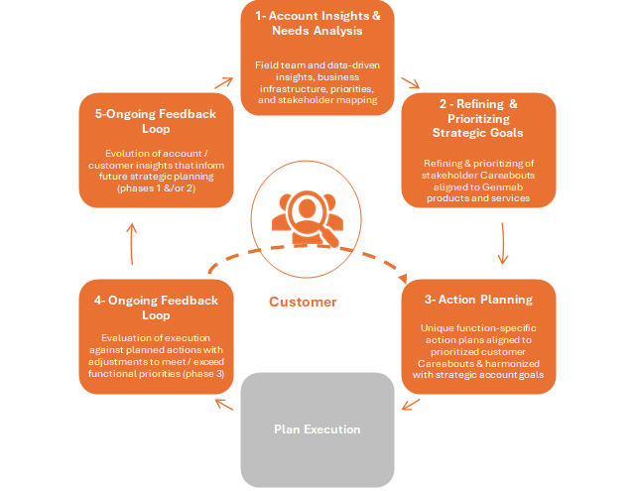

## Account plan

Each account requires the creation of a strategic account plan. An account plan consists of four required components/documents. Account team members and also optionally create any number of custom account plan components/documents as they see fit.

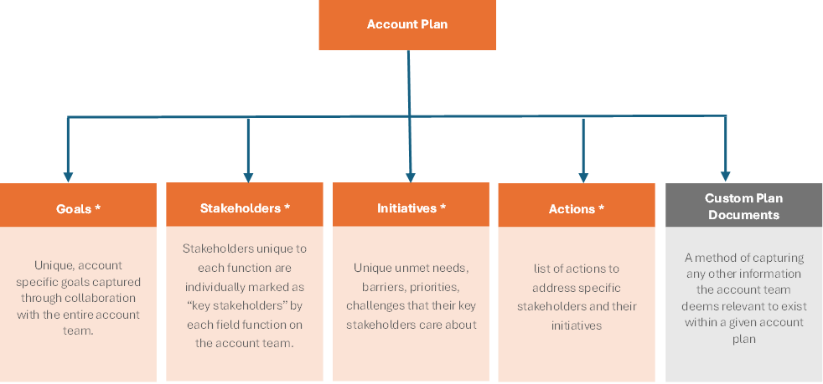

## Touchpoints across teams

Collaboration across different teams within the tool ensures a unified, strategic approach for managing high-value accounts.

* **Sales:** Leads account strategy and captures customer insights.
* **Medical Affairs:** Provides clinical input and KOL engagement updates.
* **Market Access:** Shares payer insights, access status, and reimbursement info.
* **Marketing:** Delivers tailored content and tracks campaign effectiveness.
* **Patient Services:** Highlights patient support needs and service adoption.
* **Leadership:** Oversees plan quality, alignment, and performance tracking.

## Planning cadences (quarterly, annual)



Cadences ensure account plans remain strategic, actionable, and aligned with business goals throughout the year.

* **Annual Planning**: Set strategic goals, map stakeholders, and define key account initiatives for the year.
* **Quarterly reviews**: Evaluate progress, update priorities, and align cross-functional teams.
* **Monthly Check-ins**: Track tactical execution, share updates, and identify emerging issues.
* **Real-Time Updates**: Continuously log interactions, stakeholder changes, and new opportunities to keep the plan current.

# FUNCTIONAL SPECIFICATIONS OF ACCOUNT PLANNING

### Creation of New Account Plan

An **Account Plan** can be created for each individual account, with each account being associated with a single, unique plan. Account Plans are initiated directly from the account record by selecting the **“New”** button located within the **Account Plan** section.

### Account Plan Record: Ability to quickly access linked account

### Account Plan Dashboard: Ability to view centralized account plan details

Below the account plan record, there are multiple tabs which are details, Stakeholder map, Goals, Initiatives, Document, including the **Account Plan Dashboard**. This dashboard provides various types of information such as overall plan progress, goal progress, team information, account details, goals, actions, and initiatives—offering a comprehensive view of the account’s strategic status.

#### Methodology for Calculating Overall Plan, Goal Progress, and Initiatives

1. Initiative Progress (%) = (Number of Completed Actions / Total Actions in Initiative) × 100

Example:

* Total Actions: 5
* Completed Actions: 3
* Initiative Progress = (3 / 5) × 100 = **60%**

1. Goal (%) = Average Progress of All Initiatives under the Goal

Example:

* Initiative 1 Progress: 60%
* Initiative 2 Progress: 80%
* Goal 1 Progress = (60% + 80%) / 2 = **70%**

1. Overall Plan Progress (%)/ Goal Progress = Average Progress of All Goals in the Plan

Example:

* Goal 1 Progress: 70%
* Goal 2 Progress: 90%
* Overall Plan Progress / Goal Progress= (70% + 90%) / 2 = **80%**

#### Action Details: Ability to manage account plan tasks

**Action Details** provide a summary of specific tasks within an initiative, including key information such as owner, due date, status, and related stakeholders. This helps track progress, responsibilities, and timelines at a granular level.

#### Interactions: ability to track account activities

**The Interactions section in the Account Plan Module** displays both upcoming and past interactions. Upcoming interactions show future-dated activities, while past interactions include completed, in-progress engagements.

, Picture

### DETAILS: Ability to view core account and plan info

Itprovides deeper insights through four key sections: **Information**, **SWOT Analysis**, **Customer Landscape**, and **Competitive Landscape**. These sections collectively offer a comprehensive view of the account’s background, strategic strengths and weaknesses, customer context, and competitive positioning.

#### Information: Ability to display key account and plan details

#### SWOT Analysis: Ability to capture SWOT insights

The SWOT Analysis section records the account’s main **Strengths**, **Weaknesses**, **Opportunities**, and **Threats**. This helps your team understand important factors that can impact success. By analyzing these areas, the team can align goals, initiatives, and actions to make smarter decisions and increase the chances of achieving the plan’s objectives.

#### Customer Landscape: Ability to outline customer structure and priorities

The **Customer Landscape** section outlines the Account’s **strategic priorities, key performance indicators (KPIs), challenges,** and **industry trends**. It provides a contextual understanding of the Account’s business environment to align account strategies effectively.

#### Competitive Landscape: Ability to highlight competitor presence

The **Competitive Landscape** section highlights the **competitors**, along with their **strengths and weaknesses**. It helps identify competitive risks and positioning opportunities within the account industry.

### Stakeholder Map: Ability to visualize stakeholder roles and influence

It displays the **account hierarchy**, listing key individuals along with their **names and designations** to show their roles within the organization. For example, if the account is a **Corporate HQ**, this may reflect reporting structures across regional or business units, helping teams identify decision-makers and influencers for more effective engagement.

### Goals: Ability to manage account strategic objectives

A goal is a high-level strategic objective set within the account plan. It defines what the account team aims to achieve in alignment with the customer’s needs and business priorities. Each goal provides direction, helps measure progress, and connects to specific initiatives and actions that support long-term success.

The **Goals** provides a dedicated view of all strategic objectives defined for the account plan. It outlines each goal’s status, related initiatives, progress, and key metrics—helping teams track alignment with overall account strategy and measure success over time. The above interface is displayed when the user navigates to the **Goals**.

When the user clicks on a specific goal, the interface expands to display detailed **key metrics**, as outlined in the table below. This page also shows all **initiatives linked to the selected goal**, along with their individual progress and related information, offering a comprehensive view of the goal's execution and alignment.

The **Related** sub- displays a list of all **initiatives associated with the selected goal**, providing quick access to their details, progress, and status. This helps users track how each initiative contributes to the achievement of the overall goal.

### INITIATIVES: Ability to organize and track key efforts

The Initiatives provides a detailed view of the key strategic efforts created to support account goals. Each initiative outlines its purpose, progress, and ownership. When a user clicks into a specific initiative, they can view a list of all related actions—the individual tasks that drive the initiative forward. This helps users track how initiatives are progressing and ensures that every action is aligned with a larger strategic direction.

When the user clicks on a specific **initiative**, the screen displays key details and metrics related to that initiative—such as its Title, progress and description. The user can also see a list of all **related actions**, which are the specific tasks being carried out to achieve the initiative’s objectives. This view helps users understand what’s being done, who’s responsible, and how each action supports the initiative's success.

### Documents Ability to upload and access account files

The **Documents** serves as a central place for account team members to upload and access files related to the account plan. This can include materials from interactions, meeting notes, presentations, or any other supporting documents. It helps maintain organized, easily accessible records that support collaboration and informed decision-making.

# NON-FUNCTIONAL REQUIREMENTS

* **Performance Expectations**

The SAP system should ensure swift responsiveness, with dashboards and critical data loading within 2–3 seconds under standard network conditions. Batch operations, such as data refreshes and report generation, should be completed within 5 seconds to maintain workflow efficiency.

* **Security and Access Controls**

Implement robust role-based access controls to ensure users can only access data pertinent to their roles. Sensitive information, such as strategic plans and stakeholder details, must be protected through encryption and secure authentication mechanisms like Single Sign-On (SSO) and Multi-Factor Authentication (MFA).

* **Audit Trail**

Maintain a comprehensive audit trail that logs all user activities, including data creation, modification, and deletion, with timestamps and user identification. This ensures accountability and facilitates compliance audits.

* **Mobile Access**

Provide a mobile-responsive interface that allows users to access and update account plans, goals, and tasks on-the-go. Essential functionalities should be available offline, with automatic synchronization once connectivity is restored.

* **Scalability**

Design the system to handle increasing volumes of data and users without performance degradation. This includes scalable infrastructure that can accommodate growth in accounts, stakeholders, and associated activities.

* **Availability/Uptime**

Ensure high system availability with a target uptime of 99.9%, minimizing disruptions to users. Implement redundancy and failover mechanisms to maintain service continuity during unforeseen events.

* **Disaster Recovery**

Establish a disaster recovery plan that includes regular backups and annual testing to verify data restoration capabilities. This practice aligns with industry standards, where it usually takes place annually.

* **Usability**

Design intuitive user interfaces that require minimal training, enabling users to navigate the system efficiently. Incorporate user feedback mechanisms to continually improve the user experience.

* **Data Consistency**

Implement validation rules and synchronization mechanisms to maintain data integrity across all modules, preventing discrepancies and ensuring reliable information for decision-making.

* **Data Privacy Compliance**

Adhere to data privacy regulations pertinent to the pharmaceutical industry, including HIPAA for patient data protection and 21 CFR Part 11 for electronic records and signatures. Compliance with these regulations is essential to avoid legal penalties and maintain trust.

* **Accessibility**

Design the system in accordance with accessibility standards such as the Web Content Accessibility Guidelines (WCAG), ensuring that users with disabilities can effectively use the platform.

# DATA REQUIREMENTS

Axtria SalesIQ Strategic Account Plan (SAP) module will need data input from upstream systems or entered through platform. List of data fields needed by Axtria SalesIQ SAP as input is listed below:

|  |  |  |  |
| --- | --- | --- | --- |
| **#** | **Data** | **File Name** | **Use Case** |
| 1 | Account | Account | Stores all customer or client details for managing relationships and tracking business activities. |
| 2 | Account Plan | Account_Plan__c | Contains strategic plans created for each account, outlining goals, initiatives, and actions. |
| 3 | Actions | Actions__c | Tracks specific tasks or steps assigned to team members to achieve account goals. |
| 4 | Alert - Internal Alerts | Alert__c - Internal Alerts | Sends internal notifications to the team about important updates or risks within the account. |
| 5 | Initiatives | Careabout__c - Initiative | Defines key focus areas or initiatives aligned with strategic goals for the account. |
| 6 | Custom Plan_Components / Document | Custom_Plan_Components__c - Document | Stores supporting documents related to the account plan for easy access and collaboration. |
| 7 | Goals | Goals__c | Represents high-level objectives set to drive success within the account. |
| 8 | Interactions | Interaction__c | Records all communications and meetings with stakeholders to maintain a history of engagement. |
| 9 | KPI | KPI__c | Tracks key performance indicators to measure account health and progress toward goals. |
| 10 | Market Events/ Market Alerts | Market_Events__c - Market Alerts | Captures external market events or changes that could impact on the account strategy. |
| 11 | Next Best Action | Next_Best_Actions__c | Suggests recommended next steps for the account team to drive growth and engagement. |
| 12 | Stakeholders | Stakeholders__c | Maintains details of all key people involved in the account, including roles and influence. |
| 14 | Team Members | Team_to_User_Association__c | Links users to teams and defines their roles within the account structure. |
| 15 | Team | TeamCustom__c - Team | Defining groups of users working together on the account of collaboration and management. |



**(Data Fields Requirement Document for Axtria SalesIQ)**

# ASSUMPTIONS AND CONSTRAINTS

### Assumptions

* Cross-functional teams will collaborate using the tool.
* The SAP module will integrate with existing CRM and data platforms.
* Users will be trained and supported during rollout and adoption.
* Strategic account segmentation and prioritization frameworks are in place.
* Executive and leadership support for strategic planning is available.
* A compliance and legal framework for customer engagement is already established.
* Strategic accounts will be pre-identified to ensure focused implementation.
* All users are assumed to have access to the existing CRM system.

### Constraints

* Regulatory requirements (e.g., HIPAA, GDPR) limit certain data sharing and engagement types.
* Role-based access controls may restrict visibility and collaboration.
* Limited IT and change in management resources could slow implementation.
* Integration challenges with legacy systems or poor data quality.
* Connectivity issues or limited mobile access for field teams.
* Budget and licensing constraints may limit scalability or customization.
* Implementation may occur in phases due to resources or operational constraints.

# DEPENDENCIES

* Dependency on CRM platforms (e.g., Salesforce) for account data, contacts, and activity tracking.
* Reliable and up-to-date customer, stakeholder, and product master data is essential for accurate planning.
* Input and approvals from compliance/legal are required to ensure regulatory adherence in workflows and content.
* Alignment with organizational and regional data handling and protection policies.
* Processes, communication, and stakeholder engagement to support behavioral and cultural change across teams.
* Collaboration and input from sales, medical affairs, market access, and marketing teams are necessary to build and maintain robust account plans
* Training and onboarding resources are needed to ensure adoption across cross-functional teams.
* Availability of IT resources for system integration, user access management, and maintenance.
* Availability of sales enablement content to support user training and engagement.
* Finalization of sales territories to align planning and resource allocation.

# success Metrics

The successful metrics of a Strategic Account Planning (SAP) module are key indicators that measure how effectively the strategic planning process is driving value for organization and for customers. These metrics typically fall into three categories:

* **Planning Quality** - Measure how well the account plans are created and aligned with strategy. E.g Strategic Alignment, Insight Depth, Plan Completeness & Cross-functional Collaboration
* **Execution** - Measure how well the plans are being implemented. E.g. Plan Execution Rate, Stakeholder Engagement, Initiative Completion and Data Utilization.
* **Business Impact** - Measure the outcomes and return on effort for strategic plans. E.g. Sales/Market Growth, Value Perception & Account Maturity.

# APPENDICES

### Acronyms and abbreviations

|  |  |
| --- | --- |
| SAP | Strategic Account Planning |
| CRM | Customer Relationship Management |
| KOL | Key Opinion Leader |
| HQ | Head Quarter |
| KPI | Key Performance Indicators |
| YTD | Year-to-Date |
| API | Application Programming Interface |
| HCP | Healthcare Professionals |
| NBA | Next Best Actions |
| SWOT | Strengths, Weaknesses, Opportunities and Threats |
| SSO | Single Sign-On |
| MFA | Multi-Factor Authentication |
| WCAG | Web Content Accessibility Guidelines |
| CFR | Code of Federal Regulations |
| HIPAA | Health Insurance Portability and Accountability Act, 1996 |
| GDPR | General Data Protection Regulations |